UI WEB DEVELOPEMENT

**FRONT END AND BACK END TECHNOLOGIES:**

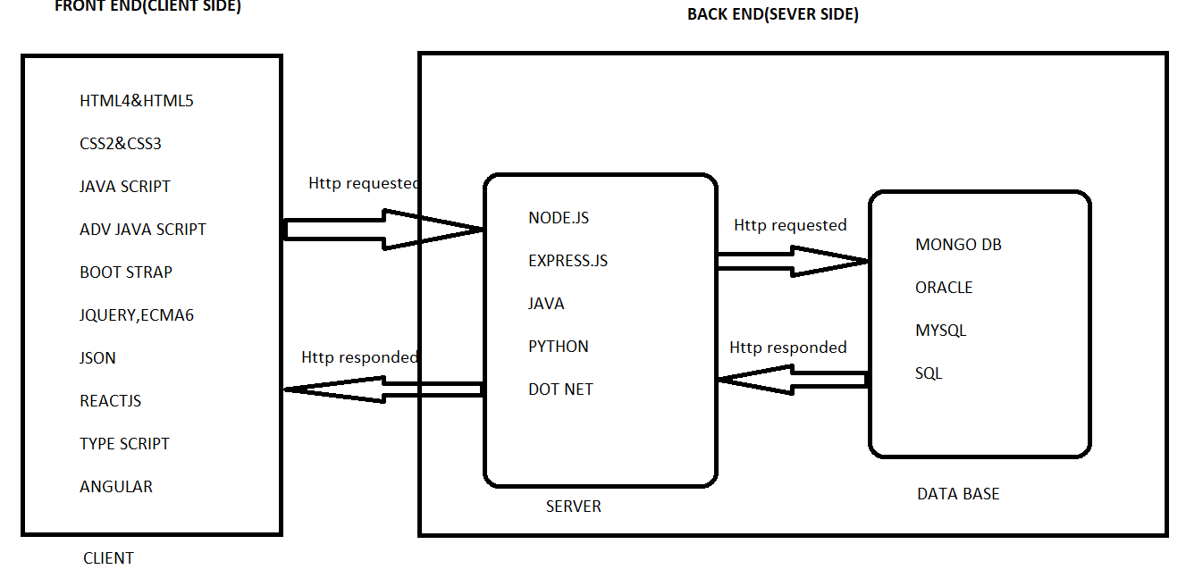

**IMG:1-(UI DEVELOPMENT &TECHNOLOGIES)**

**MERN: Mongo DB, Express. JS, React JS, Node.JS.**

**MEAN: Mongo DB, Express. JS, Angular JS, Node.JS.**

**CLIENT SIDE (FRONT END):**

**It only defines UI which a user or client will unable to access the data in the data base.**

**1. HTML-Html stands for Hyper Text Markup Language it’s a using tags. Which is capable for display the data with in the page means the user or client were unable to access the data from the data from database.**

**2. CSS-**Css stands for **Cascading Style Sheet**. In order to add beautification to the html page **.**

**3. STATIC WEB PAGES-A static web page(sometimes called a Flat Page or a Stationary Page)is a web page that is delivered to the user’s web browser exactly as stored.**

**Ex**-College Web site (Html, Css).

**4. DYNAMIC WEB PAGES-**A dynamic web site(also referred to as a database-driven site)requires web programming and database design.

**Ex**- Flip card, Google, etc. (Html, Css, Js)

**5. JAVA SCRIPT-**Java script is a text-based programming language used both on the client side and server side that allows you to make web pages interactive.

**6. ECMA6-**European Computer Manufacturers Association .Ecma6 (ES6) was created to standardize java script.

**7. BOOTSTRAP-**Bootstrap is the most popular CSS framework for developing responsive and mobile first website.

**SERVER SIDE (BACK END):**

Code written by back end developers is what communicates the data base information to the browser.

**1. NODE.JS-** Node.js is a java script run time environment built on chrome’s V8 java script engine. The basic HTTP server, We will also be using file system, path and URL, All of which are native node.

**2. EXPRESS.JS-** Express.js is a free open source web application framework for node.js .It is used for designing and building web applications quickly and easily.

**DATA BASE (DB):**

A database is an organized collection of structured information, or data, typically stored electronically in a computer system. A database is usually controlled by a database management system (DBMS).

**1. MONGO DB-** Mongo db is a document database with the scalability and flexibility that you want with the querying and indexing that you need.

**SOFTWARE USES:**

**1 .BROWSERS-** Edge, Internet Explorer, Google Chrome, etc…….

**2. EDITORS-** Sublime Text, Visual Studio Code.

**3. RESPOSITORY-** GitHub.

**4. TOOLS-** Node.JS.

**5. DATA BASE-** Mongo DB & Mongo DB Compass.

**HTML & CSS**

**HTML-** Hyper text markup language.

**Markup Language-** Language that uses tags to represent the content.

**EX-**<div>.....</div>

**Structure Of HTML:**

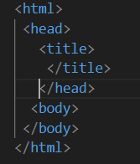

**IMG-2**

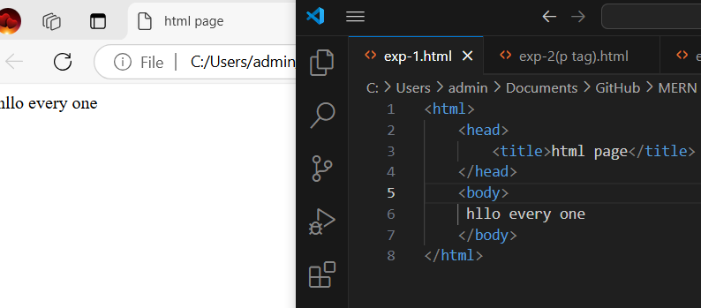

1. **<html> :** The hold complete content of the web page.
2. **<head> :** To indicate the head of the web page.
3. **<title> :** It holds the title of the web page.
4. **<body> :**To hold the actual content of the page.

**<P> Tag:** Paragraph tag used to hold the multiline text content.

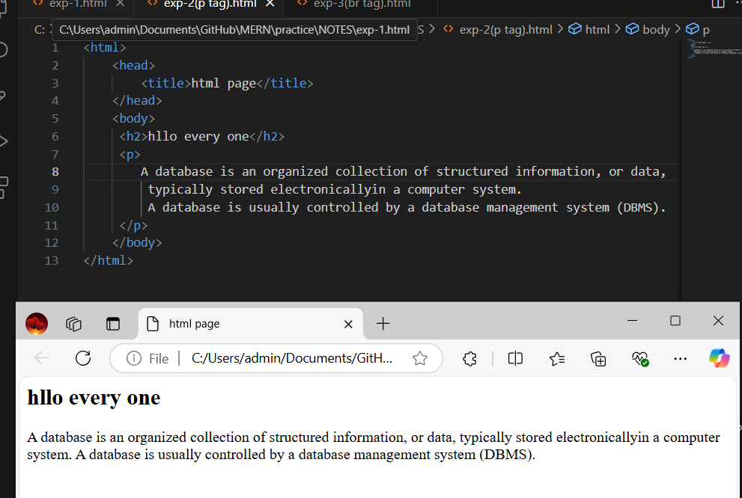

**IMG-3:Paragraph tag**

**<br> Tag**: Break tag adds single line break.

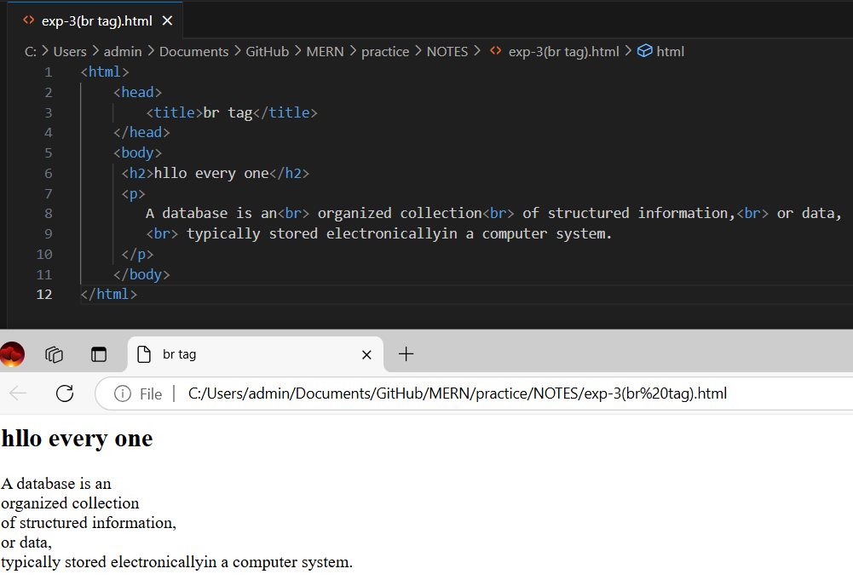

**IMG-4:BR TAG**

**CSS-**Cascading style sheet, An inline CSS is used to apply a unique style to a single element.

**STYLE ATTRIBUTE-** An inline CSS uses the style attribute of an html element. Style is a predefined tag capable of holding any no .of CSS classes.

**1. COLOR:** The CSS color indicates the text color of a html page.

**2.BACKGROUND:** The CSS background indicates the background color of a html page.

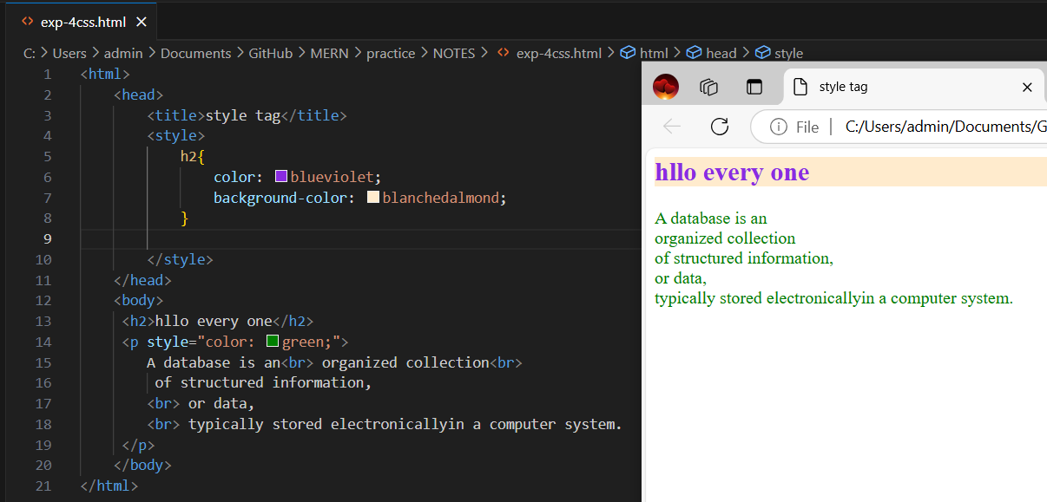

**IMG-5: CSS (STYLE TAG)**

**<span>Tag:** Inline elements to hold content in the same line. Best example for inline tag.

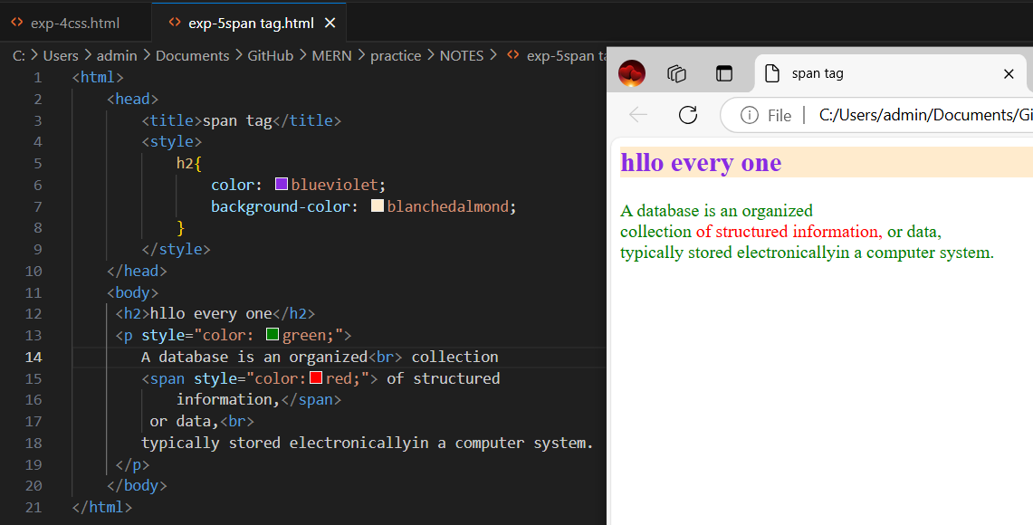

**IMG-6: SPAN TAG**

**<div>Tag:** Hold block content. Best example for block level tag.

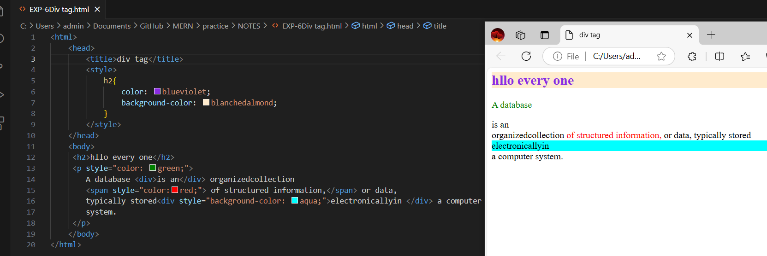

**IMG-7: DIV TAG**

**<table>Tag:** To render the content in the row and column way.

**<ol> <ul>Tags:** To render the content in ordered or unordered way.

ol Tag by defult bullet symbol is coming

ul Tag by defult numeric number is coming

**<li>Tag:** To display the list of items.

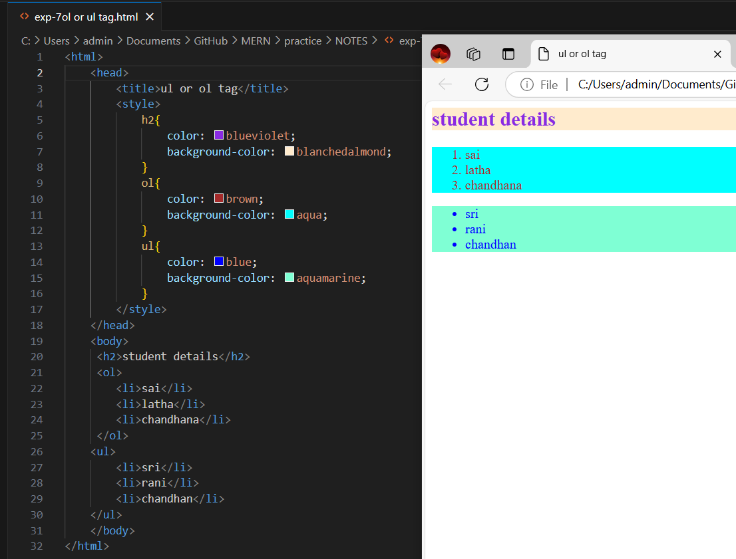

**IMG-8: OL OR UL TAG**

**HTML ATTRIBUTES:** We can add extra information to the HTML elements through HTML attributes. The attributes can be both predefined and user defined.

**1.ID -** Using which we can unique reference to elements.

**2.NAME-** Name value can be added to elements.

**3.CLASS-** Using which we can add single/multiple css classes to element.

**4.ALT-** Using which we can add alternative text content.

**5.STYLE-** To add single to multiline CSS properties to the elements.

**6.TITLE-** Using which we can add title to any html elements.